Table of Contents

**Splash Page** (User) [filename: FileControl.html Folder: Root] [Img file: nninc.jpg Folder: ../images] 1

**Admin Login Screen** [filename: loginadmin.html Folder: html] 1

**Current Activities** (all users) [filename: copystatus.html Folder: html] 1

**Portal** [filename: portal.html Folder: html] 2

• Link to **Users Screen** [filename: pcuserlist.html Folder: html] 2

o **View user activities** [filename: pcstatus.html Folder: html] 2

• Link to **Review Controlled items** [filename: reviewItems.html Folder: html] 2

▪ **View Item** [filename: viewitem.html Folder: html] 2

• Link to **Set source folder** [filename: setsource.html Folder: html] 2

• Link to **Add new Destination Path** [filename: adddestpath.html Folder: html] 2

• Link to **Administer List of Controlled items** [filename: administeritems.html Folder: html] 2

• Link to **add new item** [filename: additem.html Folder: html] 2

• Link to **set log location** [filename: setloglocation.html Folder: html] 2

• Link to **Options Page** [filename: options.html Folder: html] 2

• **Log List** [filename: logs.html Folder: html] 3

▪ **Log (Individual)** [filename: {db specific}.txt Folder: {db specific}] 3

Appendix 3

Distribution list 3

Batch file System 4

ScreenFlow 6

# **Splash Page** (User) [filename: FileControl.html Folder: Root] [Img file: nninc.jpg Folder: ../images]

* Report user, PC Name, and IP address to host
* Offer link to Admin Login Page if user is listed as admin
  + Timeout and proceed to Current Activites
* If not admin, Proceed to Current Activities immediately

# **Admin Login Screen** [filename: loginadmin.html Folder: html]

* Login Screen
* Proceed to Portal

# **Current Activities** (all users) [filename: copystatus.html Folder: html]

* Begin checking & copying process
  + From source to destination first
  + Other files copied back to server only when done with essential files
    - Copy to review folder and log
* Log the user info reported from splash screen
* Display files updated (New files being updated today)
* Display reference ( or info ) links? (i.e. Knowledgebase, machine manuals, machine database)
  + May need a list of references on the preference page
* Offer link to Admin Login Page if user is listed as admin

# **Portal** [filename: portal.html Folder: html]

* + Link to **Users Screen** [filename: pcuserlist.html Folder: html]
* List PCs receiving updates Show PC Name by date and time
  + Most recent updates at the top of the list.
  + Highlight red if last update was more than 72 hours
* Link to view user activities per user
  + Show user and IP
  + **View user activities** [filename: pcstatus.html Folder: html]
* Link to **Review Controlled items** [filename: reviewItems.html Folder: html]
  + See appendix for details.
  + Link to view item from list,
  + search for a item and go to,**…**
    - **View Item** [filename: viewitem.html Folder: html]
      * Link to **Set source folder** [filename: setsource.html Folder: html]
      * Link to **Add new Destination Path** [filename: adddestpath.html Folder: html]
  + Link to Administer List of Controlled Items (see below)
* Link to **Administer List of Controlled items** [filename: administeritems.html Folder: html]
  + Link to **add new item** [filename: additem.html Folder: html]
    - Input for source path (folder picker)
    - Input for file (or files) (file picker)
      * Text area to show files selected from this folder
    - Input for destination for each file in text area
  + Link to **set log location** [filename: setloglocation.html Folder: html]
    - User login log (from splash screen info)
    - Computers updated log
    - File Changed on client log (from current activity screen)
    - Unknown Files log (from current activity screen)
    - Obsolete Files log (from current activity screen)
    - Forbidden files log (from current activity screen)
  + Link to **Options Page** [filename: options.html Folder: html]
    - Checkboxes to switch on/off …
      * Forbidden list activities (deletion, logging, copying)
      * Obsolete list activities (deletion, logging, copying)
      * File copy process
      * Perhaps set location for logs
      * ?
* Link to view logs
  + **Log List** [filename: logs.html Folder: html]
* List all the logs
* All the logs listed must be clickable
  + On click, advance to next screen (Log (Individual))
    - **Log (Individual)** [filename: {db specific}.txt Folder: {db specific}]
* Display log selected on previous screen (log list)

Underlined lines are essensial requirements

*All pages Have navigation back to previous pages

# Appendix

Example files are on onedrive

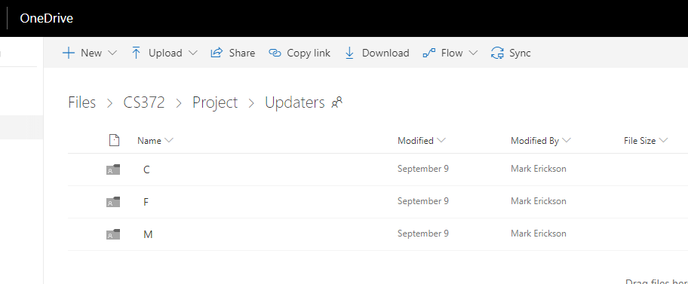

## Distribution list

All the files are MasterCam are currently controlled by a distribution list.

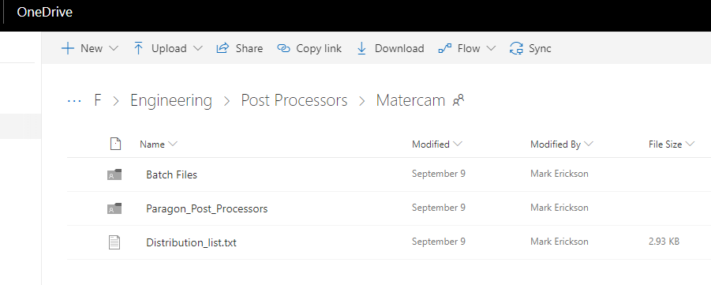

Let’s look at just one item… linie 27.

:\Engineering\Post Processers\Matercam\Paragon_Post_Processors\InI-Daewoo - 5 axis Vertical Mill#Mill

## Batch file System

The current system uses a batch file to process this line. It consists of two parts. A) the path and B) the word mill which is used in the batch file called “MasterCam-Updater_InI.bat.

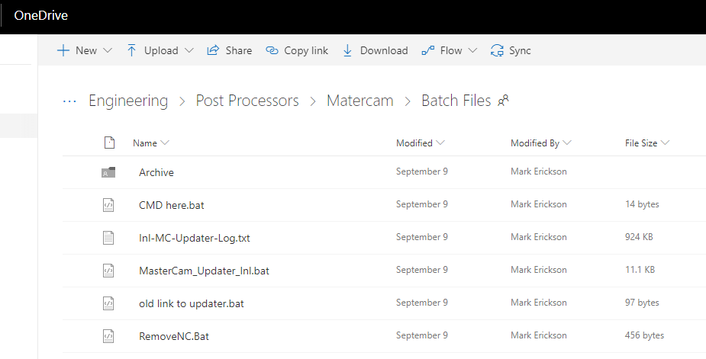

You can follow the program logic but here it is in a nutshell.

We will go to this path (The source path)..

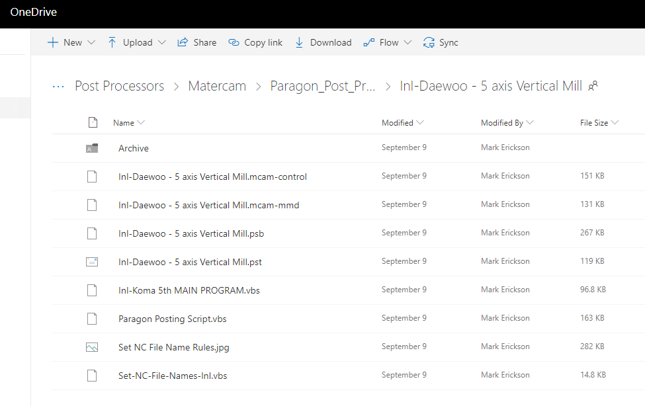

The first file ends with “.mcam-control”. This file must go to.. C:\users\Public\documents\shared mcam2018\cnc_machines.

The 2nd file “.mcam-mmd” goes to the same destination.

The 3rd & 4th file (*.psb & *.pst) go to C:\users\Public\documents\shared mcam2018\mill\posts

The 5th & 7th files (*.vbs) go to C:\users\Public\documents\shared mcam2018\vb

There is no current definition for a *.jpg

We need a window that provides us with a source folder, **a file (or files or folder)**, and a destination for each item we select.

Each of these are an “item” (controlled files) to be listed in the database.

They are to be used in one command

xcopy %source%\*.*mmd* %destinationfolder%

## ScreenFlow

